SIMATS ENGINEERING (SAVEETHA SCHOOL OF ENGINEERING) Department of Computer Science and Engineering
ASSESSMENT TOOL 1 – Coding Challenge Task
Course Code: | CSA06 | Course Title: | Design and Analysis of Algorithms
CO Assessed: | CO4: Articulation (BL4, BL5) | Assessment: | Assessment Tool 1 – Coding  Challenge Task
Weightage: | 40% of CIA | Total Marks: | 100
CO4 Statement: | Solve optimization problems using dynamic programming and greedy strategies.
Student Name: | S.MYTHILI | Reg. No.: | 192411250
Section / Batch: |  | Date: | 14/08/26

Instructions to Students
• Answer the following question. Total Marks: 100.
• Carefully analyze the given questions.
• Write clear code for the given problem.
• Analyze the Time complexity and Space complexity of your code using dynamic programming and greedy strategies

Question Type | Focus Area | Questions
Coding Challenge Task | Focus on Code and analyze optimization problems using dynamic programming and greedy strategies | Q1

SECTION A – Coding Challenge Task
Code of Conduct
I __________________________ (Name / Reg No) certify that this submission is my original work and that I have adhered to the guidelines specified for this assessment. I understand that any violation of academic integrity rules will result in disciplinary action.
Signature of the Student: _________________________

RUBRICS FOR CALCULATION
Coding Challenge Task
Criteria | Weightage | Level 4 (Exemplary) | Level 3  (Proficient) | Level 2  (Developing) | Level 1  (Beginning)
Problem  Understanding | 20% | Clearly understands problem constraints, edge cases, and  competitive  requirements | Understands  problem with  minor gaps in  constraints | Partial  understanding;  misses key  constraints | Misinterprets  problem or  constraints
Algorithm | 25% | Selects optimal  algorithm with best time and space  complexity for  competitive  constraints | Uses efficient  algorithm with  minor scope for  improvement | Uses  basic/inefficient  approach | No clear  algorithmic  approach
Code  Implementation | 20% | Writes correct,  efficient, and clean code that passes all constraints | Code works with minor errors or  inefficiencies | Partially correct  code; fails for some cases | Code does not  execute or gives incorrect results
Competitive  Performance | 20% | Solves problem within time limits and  handles large inputs effectively | Solves within  acceptable time  with minor delays | Struggles with time limits or larger  inputs | Unable to solve within time  constraints
Test Case  Handling | 15% | Handles all test cases including edge and  hidden cases | Handles most test cases | Misses important edge cases | Fails on multiple test cases

Marks Evaluation:
Criteria | Wt. | Level 4 –  Exemplary | Level 3 –  Proficient | Level 2 –  Developing | Level 1 –  Beginning
Problem Understanding | 20%
Algorithm | 25%
Code Implementation | 20%
Competitive Performance | 20%
Test Case Handling | 15%
Total Marks (100):

Faculty In-charge | Course Coordinator | Head of Department
Name: | Name: | Name:
Signature: _______________ | Signature: _______________ | Signature: _______________
Date: ___________________ | Date: ___________________ | Date: ___________________

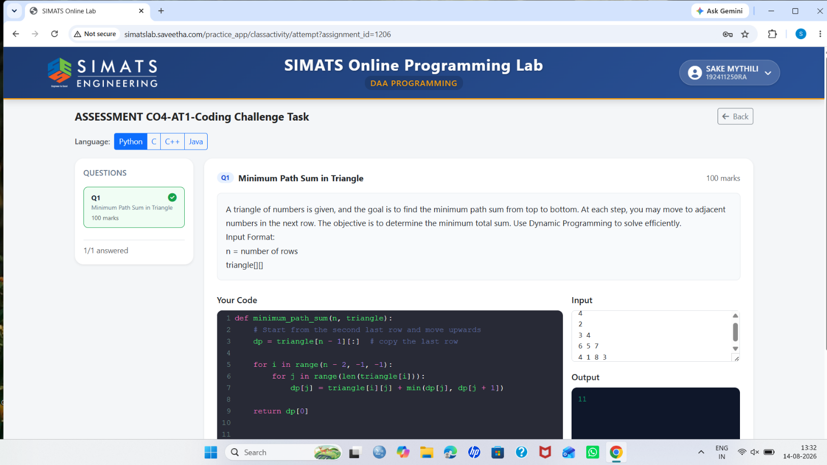

Minimum Path Sum in Triangle – Matter
Problem:
Find the minimum sum path from the top to the bottom of a number triangle. At each step, we can move to one of the two adjacent numbers in the next row.
Approach:
Use Dynamic Programming (DP). Start from the bottom row and calculate the minimum cost for each position. For every element, add its value to the smaller of its two adjacent values in the next row.
Algorithm:
- Start from the last row.
- Compare the two adjacent values below each element.
- Add the smaller value to the current element.
- Repeat until reaching the top.
- The top value gives the minimum path sum.
Time Complexity: O(n²)
Space Complexity: O(n)

